**Day 5 Assignment**

**Operating System Concepts**

An operating system (OS) is a collection of software that manages computer hardware resources and provides common services for computer programs. The operating system is a vital component of the system software in a computer system.An Operating System (OS) is an interface between a computer user and computer hardware. An operating system is a software which performs all the basic tasks like file management, memory management, process management, handling input and output, and controlling peripheral devices such as disk drives and printers.

Important functions of an operating System.

● Memory Management

● Processor Management

● Device Management

● File Management

● Security

● Control over system performance

● Job accounting

● Error detecting aids

● Coordination between other software and users

**Object Storage and Block Storage**

Block storage is the oldest and simplest form of data storage. Here, data is stored in fixed-sized chunks called — you guessed it — ‘blocks’. By itself, a block typically only houses a portion of the data. The application makes SCSI calls to find the correct address of the blocks, then organizes them to form the complete file. Because the data is piecemeal, the address is the only identifying part of a block – there is no metadata associated with blocks. This structure leads to faster performance when the application and storage are local, but can lead to more latency the further apart they are. The granular control that block storage offers makes it an ideal fit for applications that require high performance, such as transactional or database applications.  
  
**The Difference Between Object and Block Storage**Compared to block storage, object storage is much newer. With object storage, data is bundled with customizable metadata tags and a unique identifier to form objects. Objects are stored in a flat address space and there is no limit to the number of objects stored, making it much easier to scale out. The metadata tags are a key advantage with object storage – they allow for much better identification and classification of data. You can think of objects as being self-describing: They have descriptive labels assigned by the user or application that writes the object. Using a search application you can easily search for a specific object, even if the data itself is not easily searched (such as an image, or media clip, or data set).  
  
Search capabilities and unlimited scale make object storage ideal for unstructured data, a classification that is currently expected to hit 44 zettabytes by 2020. Object storage is the only option that can effectively store this data at scale.

**Linux Commands**

### **1. pwd command**

This command prints the location of your current working directory. It's important to know actually where you're before going to a parent or sub directories.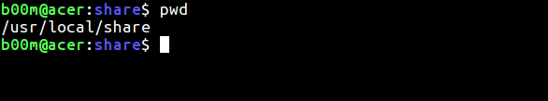

### **2. ls command**

**ls** is one of the most used basic linux commands, used to **print** contents of a directory, by default it lists contents of current working directory(**pwd**).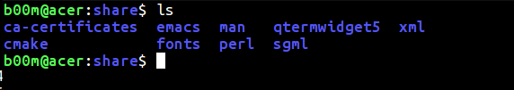

Example, use ls /usr/bin to list contents of the **/usr/bin** folder.

### **3. cd command**

After knowing your **pwd** and getting an overview with the **ls**, it's time to move around with **cd**command. Clarification, assume you're on your **Home** directory, you need to go to the **/usr/local/share/fonts** directory, use cd /usr/local/share/fonts.There's three shortcut, if you need to move one directory up, use cd .. and go straight to your Home folder with cd, and use cd - to go back to your last working directory.

### **4. cat command**

It's used to print the contents of a file to the screen(**stdout** more precisely), really useful when you want to have a quick look on contents of a file. As example, use cat a_text_file to get the inside contents of that file in your screen.

**5. cp command**

**cp** , You can copy files and directories with this command. Typical usage is like cp file_a file_1_copy or cp directory_a dir_a_copy Also don't forget to use proper path when you're coping something to different location.

### **6. mv command**

The mv command is used to **move** or **rename** directories and files. To rename a file use mv old_name new_name, more details about mv [**here**](https://www.pcsuggest.com/rename-file-linux-command-line/) and [**here**](https://www.pcsuggest.com/rename-directory-linux/).

### **7. rm command**

The rm command is used to [remove directory](https://www.pcsuggest.com/remove-directory-linux/) or files. Like use rm -r /tmp/backup to remove everything that folder. Of course you've to be careful before removing anything.

### **8. mkdir command**

**mkdir**, it's used to make a new directory in linux. Example, use mkdir my_new_dir to make a new directory named my_new_directory. The -p argument is useful, when you don't want to make parent directories manually.

### **9. rmdir command**

**rmdir**, if you need to remove a directory, use this command. As example, use rmdir my_dir to remove that specific directory. More details about the rmdir command [**here**](https://www.pcsuggest.com/remove-directory-linux/).

### **10. touch command**

**touch**, It's the equivalent command of mkdir for files. You can create a blank file with touch command. As example, use touch ~/Public/index.html to create a blank index.html file under the Public directory.

### **11. ln command**

This command is used to make link between files and directories. As example, you need to make a symbolic link of the /var/www directory to the /tmp directory.

ln -s /var/www/ /tmp/

To un-link that symlink, use

unlink /tmp/www

You've to be extra careful with complete path and trailing slashes while linking and un-linking.

### **12. sudo command**

**sudo** , that's an essential yet potentially dangerous command. Whenever you're getting a Permission denied, Authorization failed or something like that use sudo.

As example, the /var/www directory is not writable by the normal user. So to create a blank **index.html** file under the **/var/www** directory use sudo touch /var/www/index.html

### **13. head command**

If you need to print first few lines of a file(any type) then you can use head command. A nice practical example w'd be

head -20 /var/log/syslog

This will print the first 20 lines of the **rsyslogd** log to the stdout. By default head command prints first 10 lines.

### **14. tail command**

It's similar to the head command, but the function is opposite, prints last 10 lines of any file by default. Here's an example, how to print last 30 lines of the kernel log.

tail -30 /var/log/kern.log

### **15. chmod command**

It's also a very important command, used to change file and directory permission. As the chmod command is a very long topic, so here I'll explain it in brief.

Basically there's three type of permission, read, write and execute. Each of them denoted by a number.

* 4 for **read** permission
* 2 for **write** permission
* 1 for **execute** permission

So if you need to set universal read/write permission to a file, you can use

chmod 666 my_file_name

Assume you need to make a script executable, you can use

chmod +x my_script_name

There'll be a full chmod tutorial very soon, to explain you in detail.

### **16. md5sum command**

You may often need to check if a file tempered with or not. However md5sum is not the safest, but no doubt one of the most used.

An easy example could be finding the checksum of a ISO file

user@host:~$ md5sum ~/OS/slitaz-5.0-rc3.iso  
0d685551f8b0b0bd9caa3a4e66d61a3e ~/OS/slitaz-5.0-rc3.iso

The long string of numbers and digits is the md5 hash of that particular file, just match first and last two characters, that's enough.

### **17. locate command**

The basic command to find files and directories in Linux. As it's a database driven command, so for the first time you need to build the database, run sudo updatedb and wait for few minutes.

A typical example to locate something could be like below.

locate -i *chromium*

It supports wildcards, and use the -i option to ignore upper/lower case.

### **18. df command**

This command is used to check disk space usage on a linux system. The most common usage is like below, used along with the -h flag.

df -h

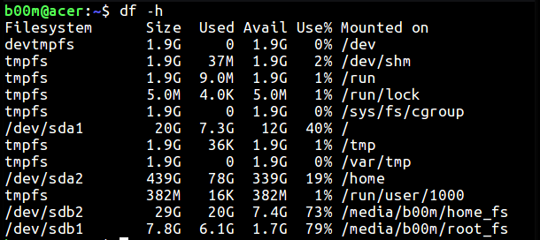

### **19. du command**

If you need to quickly check disk space usage of a file or directory, the du command is here.

For a single file, a nice example could be like below,

du -sh /boot/vmlinuz-4.10.10

Or could be like below for a entire directory and it's contents.

du -sh /opt/google/chrome/

The -s flag is used to suppress unnecessary clutter and -h flag is to make the output more human readable.

### **20. free command**

The free command is used to display amount of free and used RAM in the system, also prints the swap space stats.